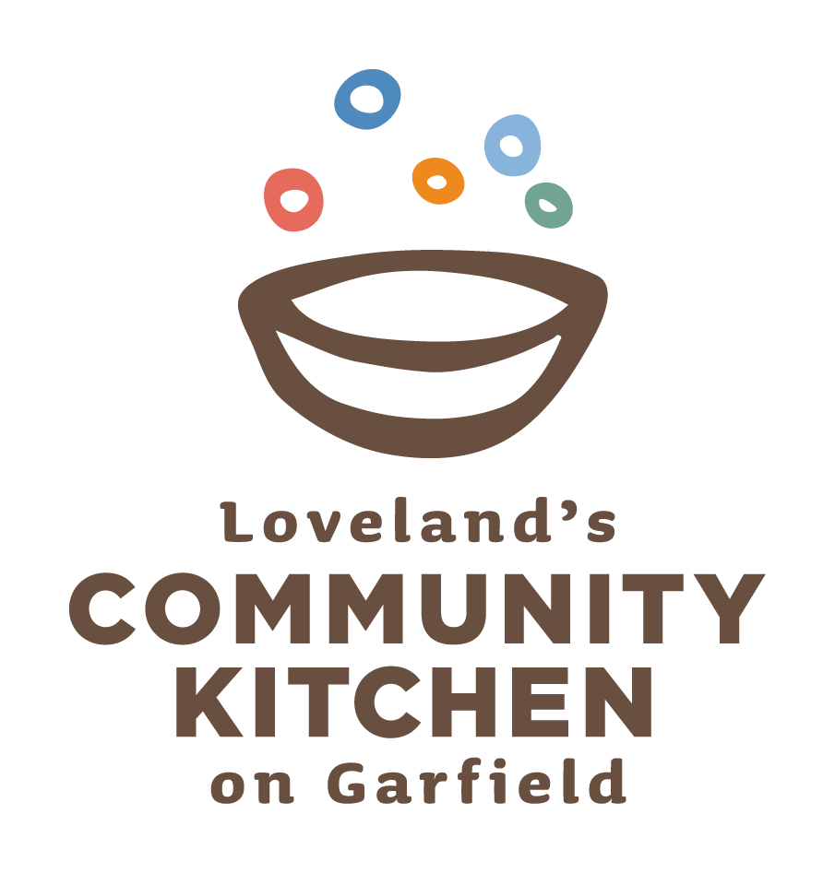

Community Kitchen Annual Cajun Boil Fundraiser
September 23, 2011

AUCTION FORM

Auction Item:

Dollar Value: Expiration Date:

Company:

Contact Person:

Address:

Phone: ______________________________ E-mail:

Signature:

Return completed form and auction item to:

Community Kitchen
437 North Garfield Ave,
Loveland, CO 80537

Or

Colorado Time Systems
c/o Anita Sayed
1551 East 11th Street
Loveland, Co 80537
970.667.1000

